 

**Placement Empowerment Program**

**Cloud Computing and DevOps Centre**

**Automate file copying using a batch script and schedule it with Task Scheduler on Windows**

**Name: Kalairajan S Department: IT**



**Automate file copying using a batch script and schedule it with Task Scheduler on Windows**

### **Step 1: Create the Batch Script**

1. **Open Notepad**:
   1. Press Windows + S, type **Notepad**, and open it.
2. **Write the Script**: In Notepad, type the following code to copy files from one folder to another:

@echo off  
set source_folder=C:\path\to\source\folder  
set destination_folder=C:\path\to\destination\folder  
xcopy "%source_folder%\*" "%destination_folder%\" /E /H /C /Y

1. **Customize the Script**:
   1. Replace C:\path\to\source\folder with the actual path to the source folder.
   2. Replace C:\path\to\destination\folder with the actual path to the destination folder.

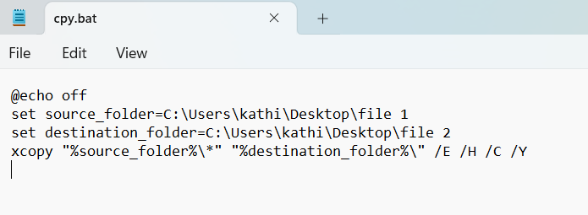

1. **Save the Script**:
   1. Go to **File > Save As**.
   2. Choose a location (like your desktop or any folder).
   3. Set the file name as copy_files.bat (make sure it ends with .bat).
   4. Change **Save as type** to **All Files**.
   5. Click **Save**.

### **Step 2: Test the Batch Script**

1. **Run the Script Manually**:
   1. Double-click on the copy_files.bat file to test it.

### **Step 3: Schedule the Script using Task Scheduler**

1. **Open Task Scheduler**:
   1. Press Windows + S, type **Task Scheduler**, and open it.
2. **Create a New Task**:
   1. In the right pane, click **Create Task**.

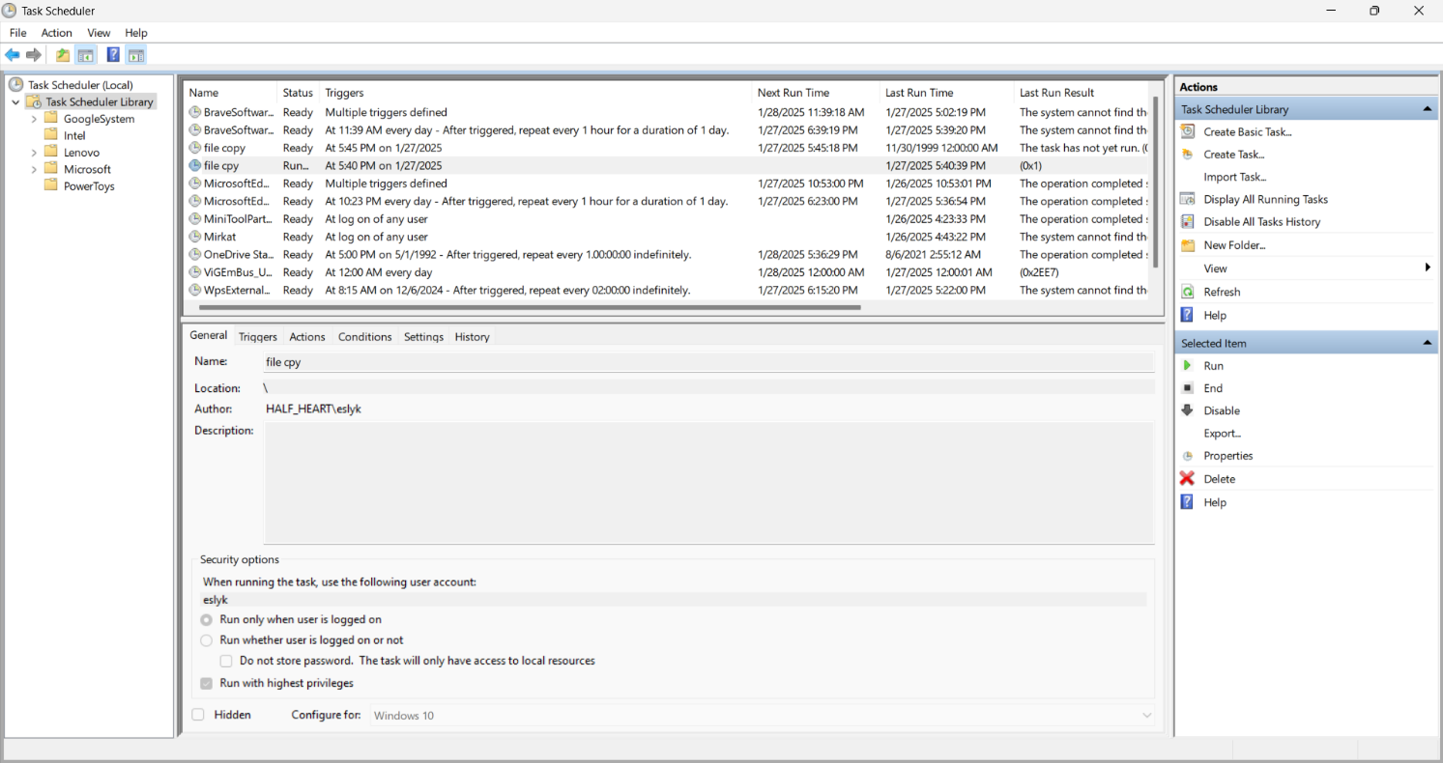

1. **General Tab**:
   1. **Name the Task**: In the **Name** field, give it a name like File Copy Task.
   2. **Choose User Permissions**: Select **Run whether user is logged on or not**.
   3. **Set High Privileges**: Check the box for **Run with highest privileges**.

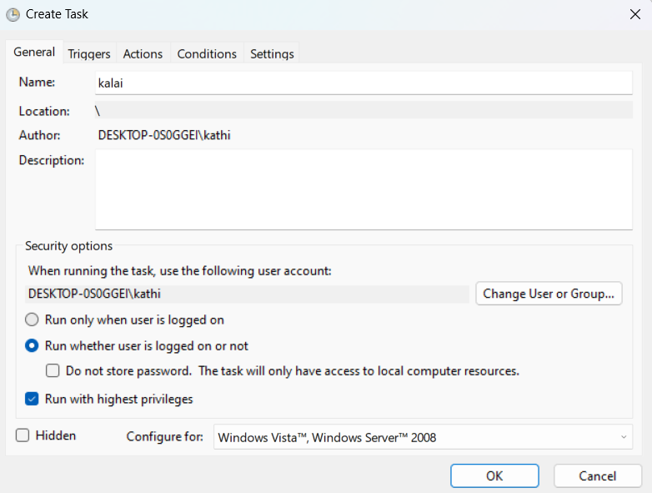

1. **Triggers Tab**:
   1. **Set the Time**: Click **New** to create a new trigger.
      1. **Begin the task**: On a schedule.
      2. **Settings**: Daily.
      3. **Start**: 2:00 AM.
      4. Click **OK**.

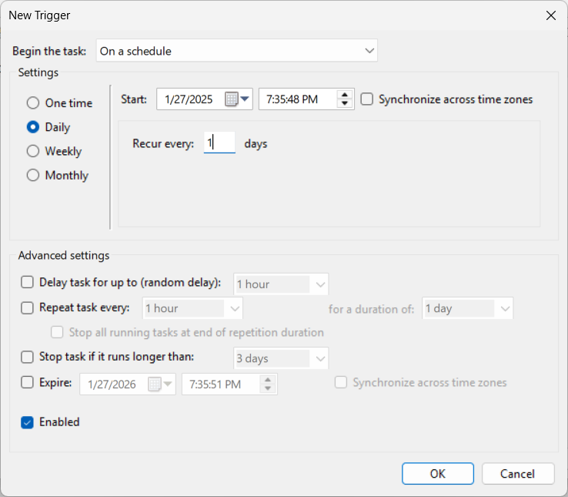

1. **Actions Tab**:
   1. **Add the Batch Script**: Click **New**.
      1. **Action**: Start a program.
      2. **Program/script**: Click **Browse** and select the copy_files.bat file.
      3. Click **OK**.

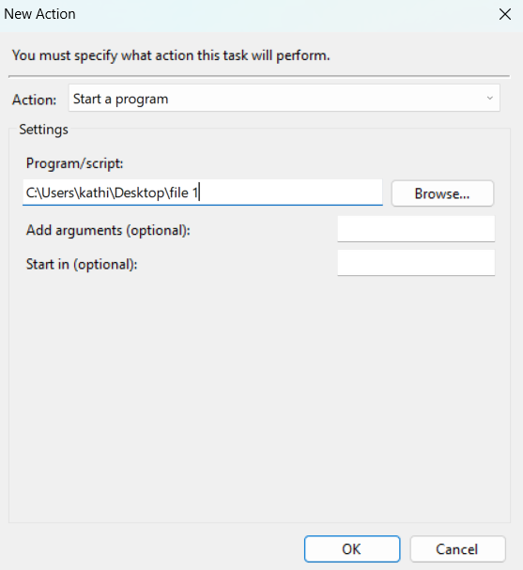

1. **Settings Tab**:
   1. Ensure **Allow task to be run on demand** is checked.
   2. Also check **If the task fails, restart every**.
2. **Save the Task**:
   1. Click **OK** to save the task.
   2. Enter your Windows password if prompted.

### **Step 4: Test the Scheduled Task**

1. **Manually Run the Task**:
   1. In Task Scheduler, find the task under **Task Scheduler Library**.
   2. Right-click the task and choose **Run**.
2. **Check if Files Were Copied**:
   1. Check the destination folder to confirm the files were copied successfully.

